Name:__________________________________ D.O.B ______________ Sex: M/F Age: _____
Home#___________________Cell#____________________Wk#________________________ E-mail:_______________________________________________________________________
Address: _______________________________________City:___________________________
State: ____________ Zip______________ S.S. #: _____________________________________
Employer________________________________ Occupation: __________________________
Marital Status M/D/S/W Spouse’s Name: ___________________________________________
Spouse's Employer__________________________ Occupation__________________________
Children: Names/ages___________________________________________________________
Referred by: __________________________________________Relation: ________________
Emergency Contact: _____________________________Phone #________________________

List Doctors, their specialty, Address/Phone #. s
1.___________________________________________________________________________
2.___________________________________________________________________________
3.___________________________________________________________________________
Do we have your permission to contact them on your behalf? Y/N
List All surgeries & dates

List All Prescription Medications: __________________________________________________

Do You wear _shoe inserts, _heel lift Do you smoke? Y/N How much: ____________________
Do you drink alcohol Y/N what/how much? _________________________________________
Is your diet Poor Fair Good Excellent Don’t know? Hours slept per night ________
What type of exercise do you do, how often, how long per week? _______________________

What is your #1 condition you want help with from us? ________________________________
When did it start? _________What do you believe is the cause__________________________
How Often does it occur? _____________________________ Is it Mild Moderate Severe
When has it occurred before? ________________________ Is it worsening? Y/N ___________
What Other Doctors have you seen for this? _________________________________________
What Treatment received: _______________________________________________________
What were your results: _________________________________________________________
What other conditions would you like help with? _____________________________________
When was your most recent car accident____________________________________________
List any other major accidents/traumas in your life____________________________________
List any chemical/medical/toxic traumas____________________________________________
Do you see your health as an investment or an expense?
Past Health History
Hospitalizations:_______________________________________________________________ _____________________________________________________________________________
Describe any Chiropractic Care You’ve received______________________________________
Where________________________________________Results_________________________
Reason for leaving _____________________________________________________________

Check all that apply
High cholesterol Allergies Sinuses Cancer__________________ Heart problems High Blood Pressure Heart Disease Asthma Vertigo Liver Disease Diabetes
Epilepsy Anxiety TMJ Ulcers Sleep Problems Thyroid Disease Hepatitis
Kidney Disease Digestive Trouble Fatigue Depression Mental disorders
ADD/ADHD Weight Problems Arthritis Joint Pain Liver Disease Sleep Apnea
Seizures Acid Reflux Infertility Paralysis Vision problems Dental problems
Hearing difficulties Earaches

Pain Indicators (check all that apply)
Upper back pain Mid back pain Low back pain Neck pain Ankle pain Hip pain
Foot Pain Radiating leg pain Radiating arm pain Wrist pain Hand Pain Knee pain Headaches Shoulder pain General stiffness

Lifestyle (check all that apply)
Stress Nervousness Allergies Loss of sleep Dizziness Forgetfulness Confusion Caffeine Under / Over Weight Skipping meals Sugar / Bad Carbs No Exercise Alcohol Nausea Vomiting Diarrhea Constipation Abdominal cramping Heart burn Gas / Bloating after meals Poor Snacking Smoker

Body Composition (check any you would like addressed)
Love Handles Wrinkles/ Age Spots Flabby arms Mommy tummy Turkey Neck
Thighs Back fat Varicose Veins Cellulite Stretch Marks
Other (please specify): _______________________________________________________
Height: ________ What is your Weight? ______ Ideal Weight? ________
Where do you have metal in your body? ________________________________________________________
Do you have a pacemaker? Y/N Other internal electronic devices? _________________________________
________________________________________________________________ Mark all areas of concern
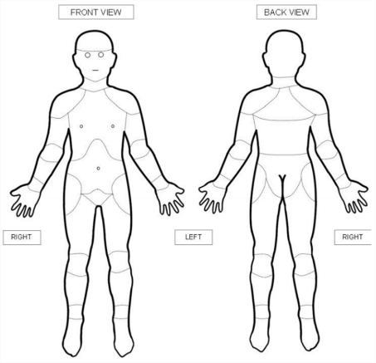
INFORMED CONSENT TO TREAT
I give the healthcare providers at the Wellness Center of Franklin LLC to proceed with evaluation and care as deemed appropriate. I understand there is no promise or guarantee of cure and that all procedures will be explained to me in advance, and that I hereby give my consent for said care.
I hereby request and consent to the performance of any needed tests, treatments and/or related procedures, including allergy relief, acupuncture, chiropractic, and/or various modes of physical therapy on me (or on the patient named below for whom I am legally responsible). I hereby consent to be treated by any licensed doctor who now or in the future treats me while employed, working or associated with or serving as a back-up doctor for the clinic named above.
I have the opportunity to discuss with the doctor and/or with other office or clinic personnel the nature and purpose of tests and treatment. I understand that results are not guaranteed.
I understand and am informed that, as in the practice of chiropractic, there are some rare risks to treatment, including, but not limited to, fractures, disc injuries, strokes, dislocations and sprains. I do not expect the doctor to be able to anticipate and explain all risks and complications, and I wish to rely on the doctor to exercise caution and good judgment during the course of the procedure which the doctor feels at the time, based upon the facts in my best interest.
I have read, or this has been read to me, the above consent. I have also had an opportunity to ask questions about its content, and by signing below, I agree to the above-named procedures. I acknowledge this consent form applies to cover the entire course of treatment for my present condition and for future conditions(s) for which I seek treatment.
Office Policy regarding insurance: If you have insurance you would like us to pre-verify for you, it is necessary that you provide that to our staff at this time. We will do our best to determine benefits, but we are not liable for what insurance does or does not pay. You as the healthcare recipient or legal guardian are completely financially responsible. We ask that all services be paid at the time of care or as otherwise agreed in writing. We do not carry patient balances.
Signature:____________________________________________________________________ Date:__________________________

